
CLEAR REFLECTION

MIRROR CATEGORY
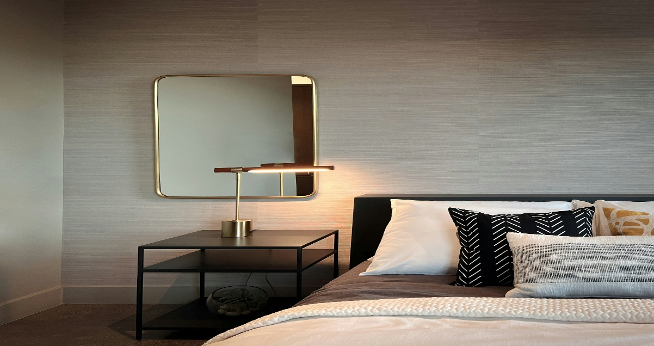
“BEDROOM MIRROR”
Bedroom mirrors are an essential element of modern interior design, combining both functionality and aesthetic appeal to enhance the overall look and feel of the space. A well-placed bedroom mirror not only helps with daily routines like dressing, grooming, and styling but also plays a key role in making the room appear brighter and more spacious by reflecting natural and artificial light. Whether it’s a full-length standing mirror, a wall-mounted design, or a mirror integrated into a wardrobe, bedroom mirrors add elegance and balance to the décor. They can complement different styles, from minimalist and contemporary to classic and luxurious, depending on the frame, shape, and finish. In smaller bedrooms, mirrors create an illusion of depth, making the area feel open and airy, while in larger rooms they act as a stylish focal point. High-quality bedroom mirrors are crafted with clear, distortion-free glass to ensure accurate reflections and long-lasting durability.

